

**A selection of your questions, thoughts and feedback….**

**While it seem the Trusts are behind this consolidation at an executive level, a number of clinical colleagues feel anxious or threatened by the prospect of services not being on site. How will the Trust executive team persuade clinicians that it will work?**

Nick Moberly responded to this question by agreeing that the Trusts are completely behind this work, but that they recognise that change is difficult. “The proverbial bus is moving”, but having said that, he recognised that there   
are difficult decisions and choices to be made (eg. hub location).   
  
The Trusts’ leadership teams have strong commitment to the process and   
believe it is an important part of their organisations’ future in a positive way. He followed up by saying that engagement with stakeholders is important and they will invest in making time for listening and taking feedback. He also reiterated the importance of the specialist and academic capability, again noting the delicate issues that will need to be worked through together.

Jules Wendon was clear that the Trust leadership will facilitate their own workshops, take opinion and feedback to the Viapath team.  
 **There is tension between the commercial case and the academic, research and innovation needs. The current Viapath Board should have more clinical and scientific representation.**

Jonathan Edgeworth said that this has been noted and that following the governance review, David Bennett, as Viapath’s new Chair, is looking into board composition.

**Clinical pathologists are concerned about the interface between patients, laboratories and clinicians, currently considered as best done through co-location. There is concern about loss of that role.**

The world has moved on and we need to find a solution and a way to retain our strengths. This can be done through planning, organisation and being innovative.

Richard Jones noted that we should also consider the virtuous circle where efficiencies drive the ability to free up cash to invest in innovation and new technology.

**Q**

**Developing a   
Pathology   
Powerhouse**

**Partners’ update:**Viapath  
Guy’s and St Thomas’   
King’s College Hospital

**Partners’ Update - clinical engagement event roundup, 2 March 2016**

**A**

**Welcome** to the first issue of our Partner’s update. We’ll use this communications channel to help keep you informed at key points on our journey towards developing a Pathology Powerhouse. This issue brings you a review of our recent clinical engagement event at the Ortus Centre on the 2March 2016.

&

.. There is tension between the commercial case and academic, research and innovation needs..  
**Beverley Hunt, Guy’s and St Thomas’ Clinical Haematology**

.. I believe people are really up for the change and ready to take the next step – they want to get on with it.  
**David Wells, Pathology General Manager**

.. Alignment of leadership and robust IT links maintaining clinical connections are essential for success.  
**Graham Taylor, Scientific Director of Clinical Genomics**

.. In 10 years time there will probably only be a handful of pathology providers in the UK. Modernising how we deliver pathology services now is undoubtedly the best way to secure our future in this increasingly competitive environment  
**Martin Shaw, Guy’s and St Thomas’ Director of Finance**

..Cross disciplinary working will drive innovation and we need to work together. The scientific community welcomes these plans.   
**Dominic Harrington, Scientific Director**

.. The two Trust CEOs set the tone for a true JV, it hasn’t felt like that previously.  
**Robin Ireland, KCH Diagnostic Haemato-Oncology**

**Message from Professor Jonathan Edgeworth, chair of the second in Viapath’s clinical engagement events**

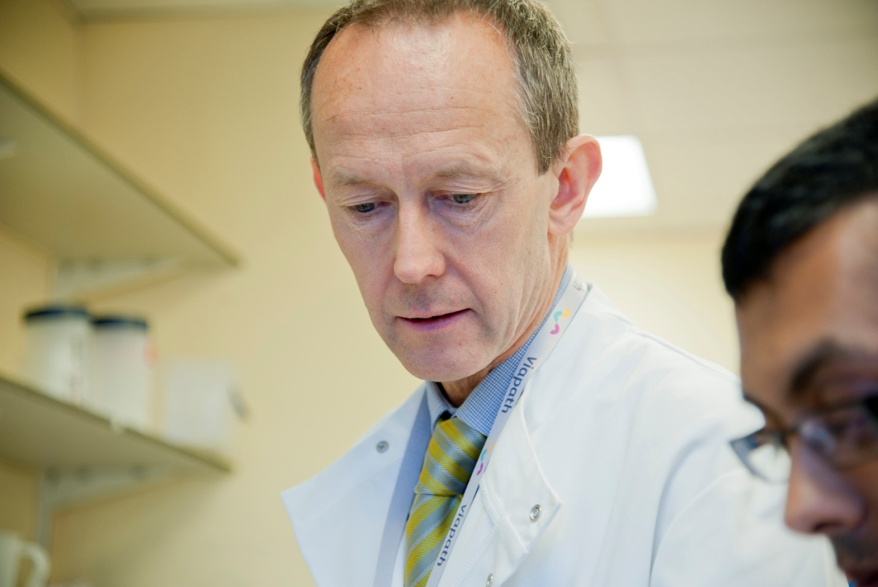 **Building a Pathology Powerhouse**

Our aspiration is to achieve what was originally envisaged for Viapath: a better pathology organisation for patients, customers, academic partners and our employees. The journey to believing that a single consolidated network is the right model takes time, but it is the best way of bringing scientists and clinicians together in a modern working and learning environment, whilst releasing efficiencies that can be used to invest in innovation and quality improvements. We recognise that many of you are still on that journey and don’t yet buy in, partly because we are so familiar with current working arrangements that have grown organically over many years, even though they are now not fit for the future challenges and opportunities we face.

**“We won’t be the first to take this journey, but we can be the best given the breadth of expertise we have across our London sites that no others have.”**  
The Clinical, Scientific and Operational group (CSO) is the vehicle that has been set up for engaging with colleagues at all London sites, and will work to share information and obtain feedback throughout the planning phase . (More about this on page 4).

**Viapath  
Guy’s and St Thomas’**

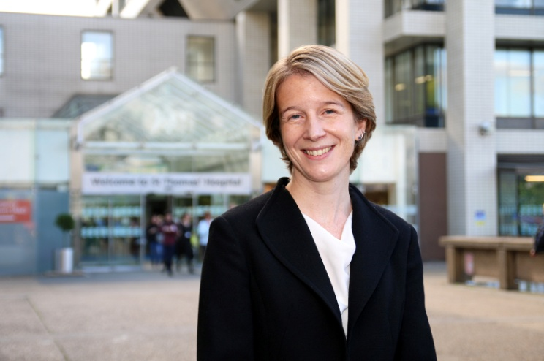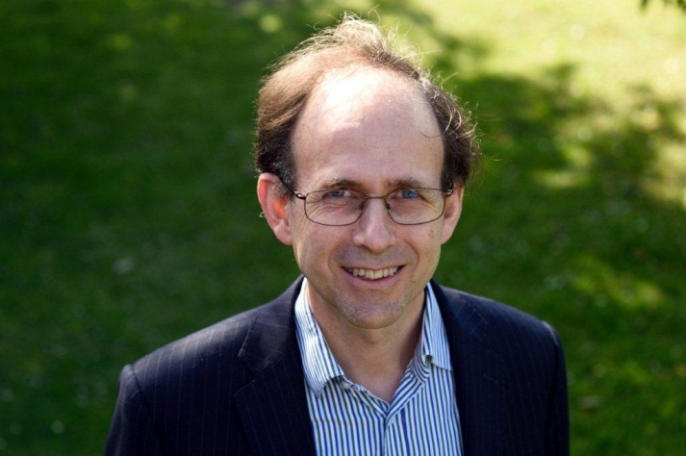

 "We are facing a period of huge change across all our services and we will all need to work very differently in future.  Viapath is not immune from these changes and we fully support the Viapath leadership team's decision to tackle these challenges head on as this will help to protect our pathology services for the future, and ensure that we remain a major provider of pathology services to our own organisation as well as to other parts of the NHS.

"Lord Carter's recent report has set a clear efficiency challenge to every NHS provider, with a strong focus on how we can all achieve greater productivity through actions that will reduce variation and increase partnership working to drive out cost.  How we manage the enormous range of pathology and diagnostic tests that our clinical teams depend on everyday has to be central to our thinking and one of the ways in which we respond to the Carter challenge.

"We therefore welcome and support the current proposals to develop a new pathology service model for South London and hope that staff will actively engage in the discussions to help shape this."

Amanda Pritchard, Guy’s and St Thomas’ CEO, speaking before the event said:  “Guy's and St Thomas' was instrumental in the creation of Viapath and the joint venture is central to our vision to deliver high quality pathology services and diagnostics to our patients.  As both a partner in the joint venture, and one of its largest clients, the success of Viapath is hugely important to everyone at Guy's and St Thomas'.

**Amanda Pritchard, CEO Guy’s & St Thomas’**

**Nick started by explaining** how the NHS Five Year Forward View has set out the challenge for the NHS to deliver £22 billion in efficiencies from the service.

**Nick Moberly, King’s College Hospital CEO shared his view of the NHS context and the exciting challenge for pathology**

**4**

**1**

It’s an incredibly tough challenge given the track record of the NHS delivering efficiencies over the past five or six years since the financial crisis and tightening of public expenditure.

This pressure translates to NHS providers being   
almost universally in deficit (current estimate £2-£3 billion).

Given this intense focus on efficiency and cost control, pathology is seen as an opportunity for consolidation to drive quality and efficiency. Carter has recently put pathology right back at the top of the NHS efficiency agenda.

Nick was keen to clarify that while this context may sound negative, there is an optimistic view we can take: KCH has been through a rough time in recent years but the leadership team recognises that there is a way forward. We need to move to financial sustainability, set our sights high in terms of the type of organisation we want to be and meet our aspirations to provide a consistent, sustainable, world class service for patients.

There are a number of opportunities to drive improvements through efficiency. We need to move to transformational mode and rethink the way we operate. In 2015 KCH achieved “financial grip”. In 2016 and 2017 KCH will invest in transformation and structural changes, and the trust’s long standing relationship with GSTT is central to that thinking.

In addition, KHP is a powerful vehicle to take the partners’ aspirations forward, particularly given the focus on the research and teaching agenda for high end specialties. Nick stated his determination to build on KCH’s relationship with GSTT, which for pathology means a commitment to developing a joint capability under the Viapath banner.

He went on to talk about the serious conversations to be had about how pathology should be organised to excel at R&D and garner the benefits of the scale.

Pathology could be organised in a more integrated way to support quality, performance and to yield financial savings. Others have made progress in this area, and we have an opportunity, particularly given we already have the vehicle and can build on an important strategic partnership.

**“Re-think in a profound way, the pattern of pathology”**

However, it is important to remember that this is not just about saving money, although this is obviously important in the current environment. It’s clear we can’t stay where we are and need to rethink our strategy for pathology. This includes how we work together with GSTT, Viapath, and Serco to offer services to our own organisations but also to others. There are increasing opportunities to extend into new business at this time when many organisations are considering changing providers or outsourcing pathology for the first time.

In summary, Nick said “this is a delicate but important topic and we need to have a sensible constructive conversation with our clinical and scientific colleague, recognising the importance of engagement, dialogue and discussion at all points of the business case development. It is not a group of people doing this in isolation – we need to create a future working with the Viapath team and Trust executive teams to make a success.

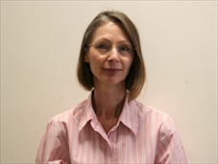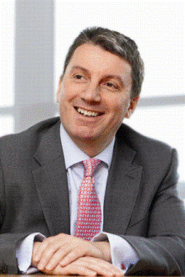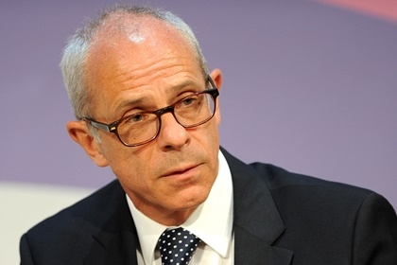

Jules provided the audience with a timely reminder that patients – in the wards, outpatients or in the community need to receive a high quality, responsive pathology service and that it’s our role to provide it. She went on to give her perspective of what the difficult questions are that we collectively need to confront:

* What could and should be centralised with regard to laboratory services?

How does this balance with the need to meet urgent on-site requirements for many of our inpatients and how would a hot lab function for each acute site and which services would be provided there?

* How will point of care testing be delivered?
* How will the clinical, translational and basic research be integrated into the proposed laboratory services?
* How do we deliver bench to bedside and bedside to bench research and development while delivering the service optimally?

We need to understand the different components of the service, challenge ways of working and proposed solutions and discuss these in a way that enables comments and feedback to be included in the business case.

We also need to be clear that we need to continue to deliver an excellent service for users and patients. We should bear in mind the dramatic changes in clinical and laboratory services over the past five years, for example Genomics, PCR, precision medicine and point of care testing. We need to be ahead of the game going forward and optimise the service for all.  
  
Through engagement and discussion we need to be prepared to confront difficult questions and distil what is optimal for the health service as a whole. Teaching and research Institutions, district general hospitals and community based users all need to be part of our process. In the next phase of work we will need to engage with wider stakeholder groups and hold workshops to ensure we take all groups into account.

**“What is optimal for the Health Service   
as a whole?”**

**Reference site visits – UK, Europe and North America taking place to inform our thinking around the:**

* Key technology and clinical pathway changes over the next 5-15 years
* Test repertoire to be retained on site
* What could/should go to a shared hub
* IT and logistics requirements
* Workforce implications
* R&D capability required - how to deliver it remotely across the network
* Clinical model
* Economic efficiencies - are they sufficiently attractive to raise funds for a new configuration.

**Stage 3: Full Business Case (FBC) -  
A detailed plan of what we will do,   
how and when**

As our thinking develops through the process, we’ll be working with our partners  
 to review the OBC draft we deliver in April, address feedback and concerns and gain   
sign off.

We anticipate the final stage of preparing   
the FBC will take 6-9 months to complete following OBC approval.

**Stage 2: Outline Business Case (OBC) - assembling the evidence to test our hypothesis**

* Evidence the benefits to the NHS, in terms of future patient pathways, quality and value for money
* Feasibility and risks
* Scope the economic case

The goal is to complete a draft of the OBC by the end of April, while also increasing engagement with our wider stakeholders.

This will ensure we understand and respond to the views of those who have an interest in the proposal.

**“Only when we are satisfied that we have adequately addressed stakeholder feedback will Viapath and Trust Boards be asked to approve the OBC**. **“**  
  
Hopefully this will take place in May/June.

They are both the customers of our service and the owners of Viapath – Guy’s and St Thomas’ and King’s College Hospitals and Serco.

The partners are following the normal business case development pathway used by the NHS and public sector to propose a strategic investment in a major service development – a similar process was applied to the Guy’s cancer centre project.

**Stage 1: Strategic Outline Case - our hypothesis:**

* Current legacy network within Viapath is not fit for the long term   
  and needs significant modernisation to meet future clinical requirements
* Laboratory quality and efficiency will be optimised by the two trusts combining their pathology capability and operating as an integrated network
* Viapath is the optimal vehicle for raising funding, implementing the transformation and delivering the service on behalf of the partners.

**3**

**2**

Richard opened with a reminder of the principal partners who will be   
making the decision on our plans for a new pathology service model   
for South East London.

**Developing our business case – the principles and governance,   
Richard Jones,   
Viapath CEO**

**Our clinical engagement plan:**

There is broad agreement on the changes needed, which is encapsulated in the Five Year Forward View. However, with the limits on funding this is very difficult to deliver. There are workforce shortages and increasing requirements to transform Information Technology and Information Systems.

**“Pathology is a microcosm of the challenges and opportunities facing the NHS acute sector, and Carter’s vision articulated in his report eight years ago has not yet been delivered.**

**With outstanding   
organisations such as   
Guy’s and St Thomas’ and   
King’s College Hospitals, there is no reason for us not to be the pre-eminent provider of pathology in the UK and   
potentially further afield”**

**David Bennett, Viapath Chair**

David Bennett’s presentation shared the theory behind Foundation Trusts and some of the reasons why they have been finding themselves financially challenged. He explained that FTs are not heavily regulated with Monitor only stepping in when Trusts get into difficulty. This has been happening more and more, partly financially driven, although the NHS has had its overall funding protected unlike other areas in the public sector.

However, while funding has been increasing at around 1% above inflation, costs are increasing at 4%, implying that there is a 3% gap needing to be filled through efficiency savings. Historically, acute providers are achieving only 0.8% per annum efficiency.

In addition to the financial constraints, the healthcare needs of our population are changing, with 70% of NHS resources being devoted to patients with long term conditions, which requires a different service provision. Key requirements are arising in increased integration, early intervention, and prevention.

**Keeping the patient at the centre of what we do, Professor Julia Wendon, KCH Medical Director**